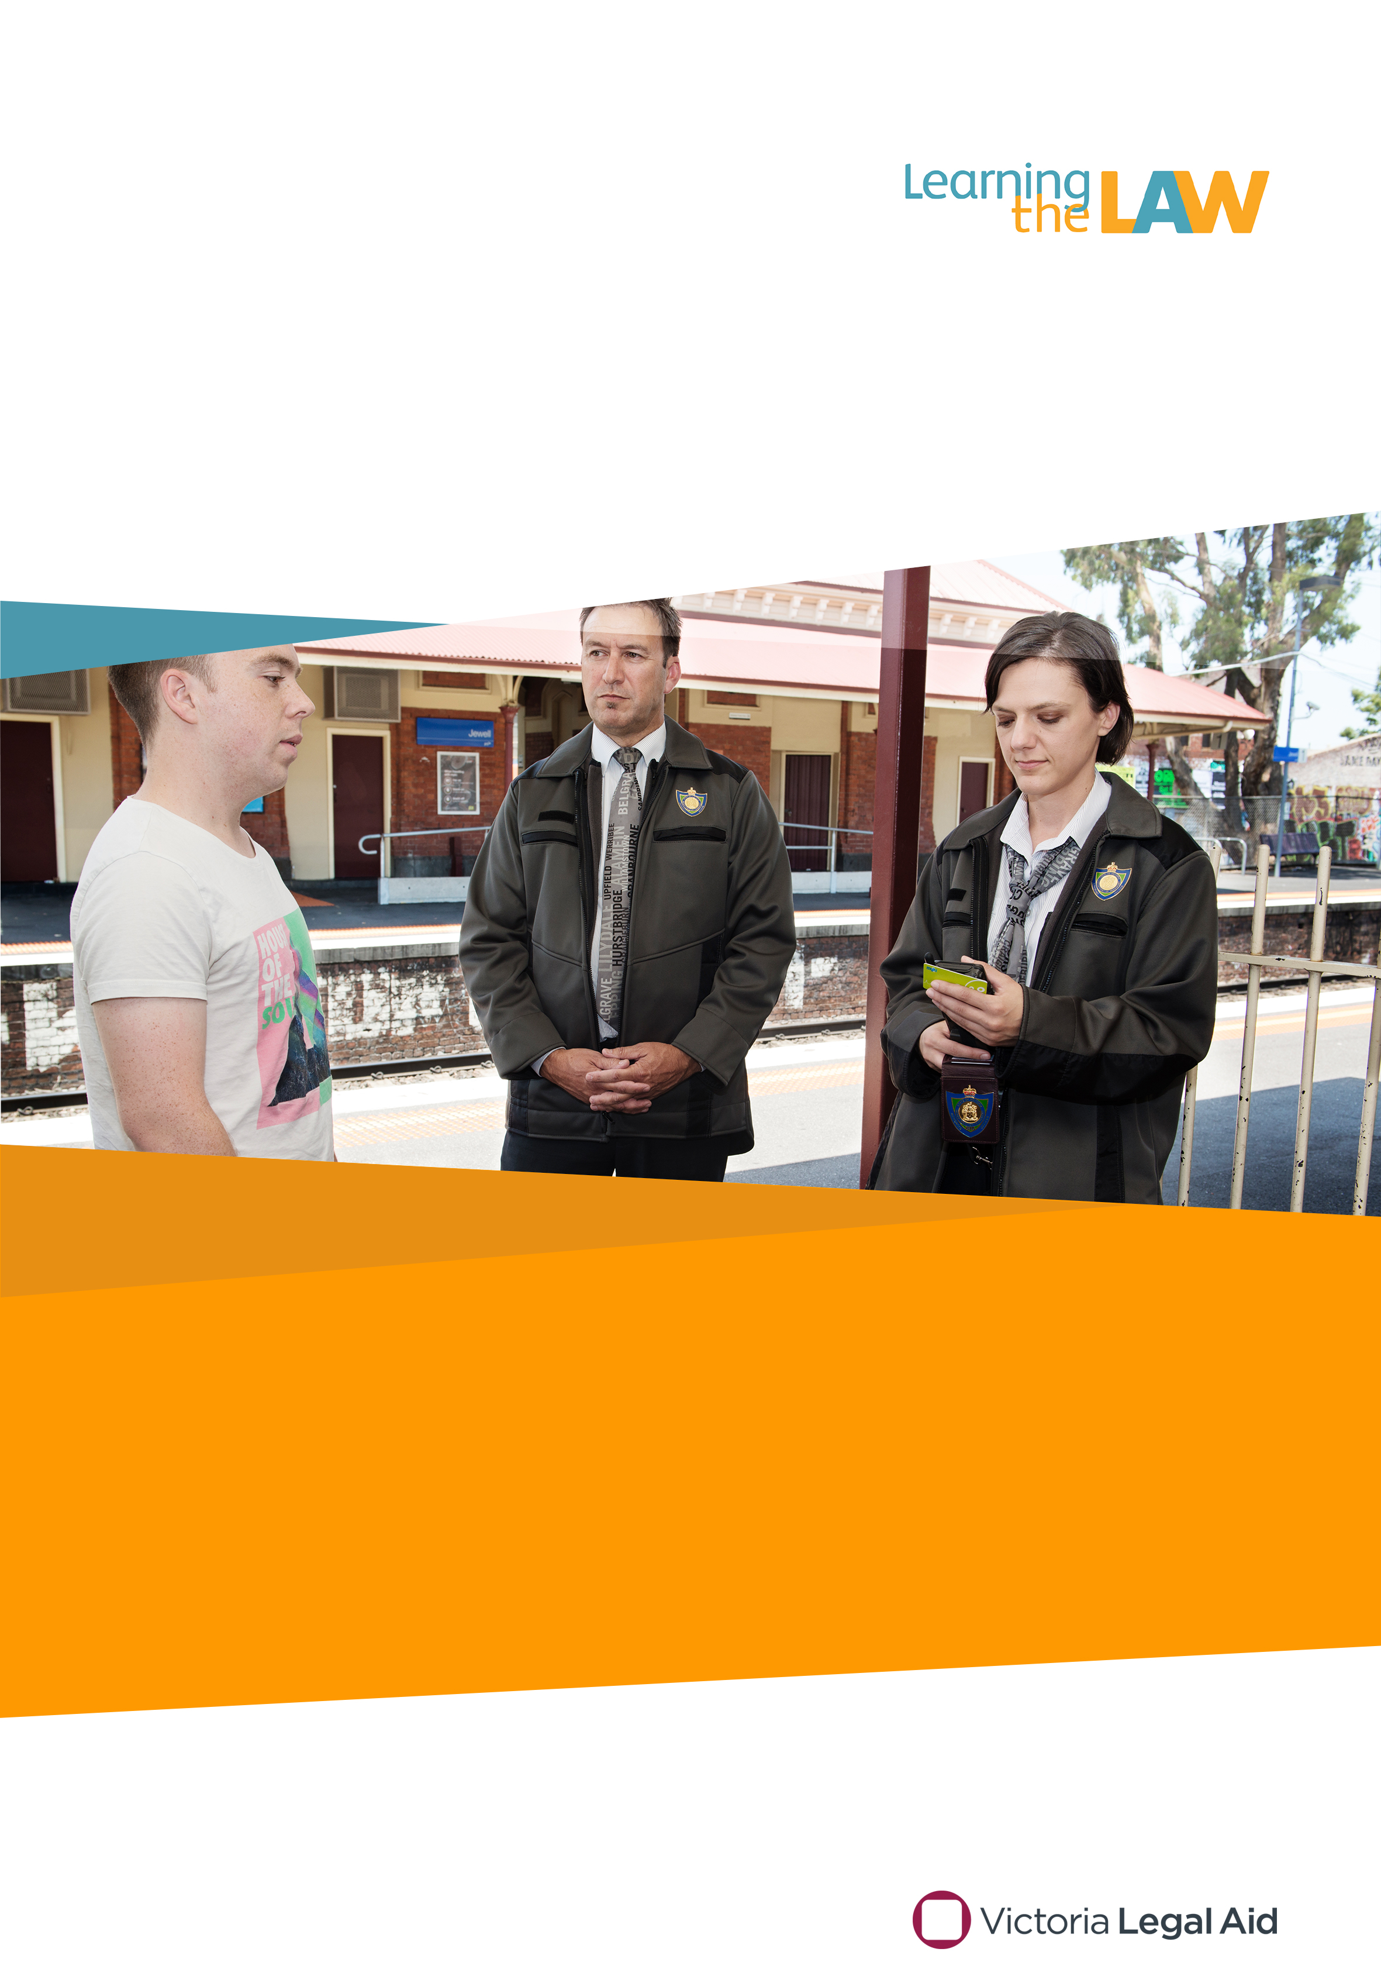
June 2018

Does Community Legal Education work?
Researching the impact of the Learning the law education kit for young people with a mild intellectual disability
Authors: Allyson Hose, Monica Ferrari and Dr James Baglin.

June 2018

Published by the Community Legal Education Program, Victoria Legal Aid

Contact: cle@vla.vic.gov.au

© 2018 Victoria Legal Aid. Reproduction without express written permission is prohibited.
Written requests should be directed to the Community Legal Education Program, Victoria Legal Aid, 570 Bourke Street, Melbourne Vic 3000.

Contents
Acknowledgements 1
Acronyms 2
Introduction 3
Background 3
Evaluating community legal education strategies 3
Evaluating the Fines module 4
Aims and research questions 4
Aims 4
Research questions 5
Methodology 6
Research design and implementation 6
Data collection 6
Development of the survey 6
Scoring participants’ responses 7
Participants 7
Interviewing 7
Data coding 8
Limitations to methodology 8
Ethics approval 9
Data analysis and results 10
Sample characteristics 10
Data analysis 11
Results 11
Travel method by condition and type 12
Unanticipated result 14
Conclusion 15
Does Community legal education (CLE) work? 15
Future considerations 16
Distribution of this report 16
Appendices 16
Appendix A: Information sheet and consent forms for parents and participants 17
Appendix B: Pre survey 23
Appendix C: Post and follow-up survey 29
Appendix D: RMIT report 35
Appendix E: Ethics approval 49
Appendix F: Accessible reports for participants 51

Acknowledgements
Victoria Legal Aid would like to thank:
Interviewers: Angela Costi, Annie Davis, Monica Ferrari, Allyson Hose, Michele Lee, Kenton Molloy, Natalie Purcell, Larissa Salinas, Andrea Staunton, Mark Tregonning, Stephanie Veljanovski, Kimberley Young.
Dr James Baglin, School of Sciences, Mathematical Sciences, RMIT University.
Dr Paul Weldon, Australian Council for Educational Research.
Staff of the Victorian Department of Education and Training.
Members of the Principals Association of Specialist Schools Victoria.
Principals, staff and students in Victorian specialist schools, in particular Berendale, Croxton, Heatherwood, Marnebek, Naranga, and Warringa Park.

Acronyms
CLE Community legal education
CLC Community Legal Centre
DET Department of Education and Training (Victoria)
DOJR Department of Justice and Regulation (Victoria)
EAL English as an additional language
JHREC Justice Human Research Ethics Committee
TEF Travel Education Framework (Victoria)
VLA Victoria Legal Aid

Introduction

Background
Learning the law is an online teachers’ kit of simplified education materials addressing the legal issues associated with fines, driving, sexting and consent. Victoria Legal Aid’s (VLA’s) Community Legal Education (CLE) program produced the kit for high school teachers of students with a mild intellectual disability. It includes lesson plans, short videos, teachers’ notes and online modules of interactive activities. The kit was launched in 2015 with modules on two topics – fines and driving. Additional modules on sexting and consent were added in 2017. These topics were chosen after extensive consultation with principals and teachers in specialist schools about what sort of legal education would benefit their students. The Department of Education and Training was also consulted and their specialist staff provided advice and support in the development of the project. Victoria Legal Aid provides free professional development sessions for teachers in Victorian schools to assist them to use the modules in the classroom.
This study was planned from the outset of the project and focuses on the Fines module of the kit. This module addresses public transport infringements and contains clear messages to help young people understand their legal rights and responsibilities when travelling on public transport in Victoria.

Evaluating community legal education strategies
In Australia, legal aid commissions and community legal centres have offered CLE programs since the 1970s. In Victoria, community legal education is a statutory function of legal aid, notably education for sections of the public who have special needs is specifically mentioned in the Legal Aid Act 1978 (Vic). VLA’s obligation to initiate programs designed to promote an understanding of the law by the public is supported by a CLE program that specialises in content development and community engagement.
Historically, the CLE program at VLA has focused on publishing plain language print and, later, web-based information for the broader public, and sections of the population identified as having a high need for legal information. In the last decade, however, CLE strategies have widened to include digital innovations and face-to-face education, in particular to teachers, workers and intermediaries with direct access to more vulnerable or ‘difficult to reach’ communities. The program often collaborates with other agencies to create educational kits for use by non-legal practitioners to educate others about the law.
The shift from print based strategies to targeted, longer-term projects that are often resource intensive, coupled with rapidly increasing demand on the legal assistance sector, have resulted in a sector-wide focus on the evaluation of CLE strategies. We need to know what CLE works, for whom and in what circumstances. This evidence enables us to innovate and provide communities with the right legal information in the right format at the right point in time, to most effectively meet their needs. This was the context in which we set out to evaluate our Learning the law Fines module.

Evaluating the Fines module
Evaluation of CLE can be conducted in many ways, from small-scale surveys and information gathering with stakeholders, to legal reviews by subject matter experts, to large research-based evaluations. We knew, in the early stages of planning the Learning the law project, that we wanted to conduct a larger study to gather evidence about the impact of CLE, to contribute to an emerging body of knowledge generated by recent research about the impact of CLE resources in Australia, Canada and the UK.
We built on the methodology applied in an earlier research project that focused on an education kit called What’s the law? Australian law for new arrivals. That study looked at the impact of CLE about legal issues associated with buying a car, provided as part of a program for adult migrants and refugees participating in English language classes. The study found that there was a statistically significant improvement in the students’ understanding of the legal issues associated with buying a car after they participated in a class on consumer contracts using the What’s the law? kit.
The involvement of CLE staff in the What’s the law? study, coupled with VLA’s growing investment in evaluation and research, built the capacity of VLA staff to undertake more rigorous evaluation. The methodology used in the What’s the law? study was replicated and improved in this study that focused on the Fines module in Learning the law. This approach leveraged expertise in the CLE program and addressed the limitations identified in the initial study. This is discussed further in the methodology section.

Aims and research questions

Aims
In embarking on a study of the Fines module of Learning the law, we aimed to gather data to determine whether the module improved participants’ knowledge and understanding of legal issues related to fines and public transport. We also wanted to know whether any change was sustained over a longer period of time and whether change would occur without the education.
Our aims in this study were to:
- conduct ethical and effective research to gather data about the impact of a CLE intervention for students who participated in a class about fines, using the Learning the law module
- generate rigorous data to assess the value of the program for students, to assist in decision making about the future of the program and to inform CLE projects more generally
- publish a report on the impact of the Learning the law Fines module and contribute to an emerging body of work about the effectiveness of CLE
- model evaluative research in the legal sector that is affordable, achievable and rigorous.

Research questions
Our research questions were designed to investigate whether delivery of the Learning the law Fines module resulted in:
- a measurable improvement in participants' understanding of their legal rights and responsibilities on public transport in situations where they encounter Authorised Officers or receive an infringement notice for an alleged offence on public transport.
- participants feeling more confident in dealing with legal issues and infringements associated with public transport and in seeking help if required.

The study was built around assessing participants understanding of the key messages in the Fines module, which are:
- Always travel with the correct myki and have enough money on your myki. Touch on and touch off properly when using public transport. This will help you to avoid legal problems with public transport fines.
- Stay calm if Authorised Officers approach you. You must show them your myki and proof of any concession. You must give your name and address and proof of your identity if they ask.
- Authorised Officers can hold you until police arrive, if they think you’ve done something wrong. If you think a situation was unfair, or you were discriminated against or treated badly by Authorised Officers, you can make a complaint. Get help from Victoria Legal Aid if you want to make a complaint.
- If you’re worried about a fine, or if you get a letter about a fine, get help straight away. Talk to an adult you trust or call Victoria Legal Aid. Don’t ignore the fine and don’t put off talking to someone about it as the fine could increase. Get help early and you’ll have more options for dealing with the fine.

Methodology

Research design and implementation
To answer the research questions, we used a quasi-experimental design with repeated measures. We interviewed participants in four schools before and after they received an education session using the Fines module in Learning the law. Half of the schools involved in the study were allocated as ‘control schools’, where participants did not receive the fines education session until after follow-up interviews. The use of a control group enabled us to assess whether participant’s knowledge, understanding and confidence changed without education about fines. We established a base line of participants’ knowledge and understanding through interviewing students in the control schools. These participants were interviewed across the same approximate time spans as participants in the test schools. The test and control participants were based in separate schools.
We also conducted follow-up interviews four months after the pre and post interviews to investigate whether any changes in participants’ knowledge and understanding of the legal issues were sustained over a longer period of time.
The research involved young people under 18 with mild intellectual disabilities. This necessarily increased the ethical considerations and meant particular care was required in designing and implementing the study. These issues are discussed below.

Data collection
Data was gathered via a survey that was delivered orally in an interview setting. VLA staff interviewed participants in one-on-one, face-to-face interviews at each of the three data gathering stages (pre, post and follow-up) [see Appendices B and C]. Interviewers manually recorded participants’ responses during interviews. Interviewers wrote down participants’ responses as accurately as possible using the language the participant used, without summarising or editing responses.

Development of the survey
The survey was developed and tested over a six month period and in consultation with Dr Paul Weldon from the Australian Council for Educational Research (ACER), Dr James Baglin from RMIT’s School of Science, special school teachers, students and interviewers.
The survey had thirteen questions that were simple and clear. The questions were constructed to avoid putting participants under pressure or generating any anxiety, for example, about the possible legal consequences of forgetting to touch on. The questions were grounded in the key messages about public transport and fines contained in the Fines module and designed to investigate whether participants understood these key messages.
Question one asked students how they got to school most days. This question was seen as an important control variable to be included in the analysis. If a student regularly travelled on public transport, they may already have knowledge of public transport rules and fines. Therefore, it was possible that the effect of the Fines module would be moderated when compared to a student that did not travel to school via public transport. In situations where students caught multiple forms of transport including both private (school bus and/or car) and public, their transport method was recorded as public. This is because these students would still be exposed to public transport rules. Some students commented that they used public transport on weekends, but this was reported haphazardly and could not be consistently coded for all responses.
In March 2016 we tested the draft survey with three interviewers and six volunteer students (from years 10 and 11) at Berendale School in Hampton East. The students had all been taught using the Fines module.
Early drafts of the survey included multiple-choice questions. However, feedback from ACER and from RMIT staff indicated that this approach risked prompting recognition from participants rather than testing recall. It could have also encouraged participants to guess and/or provide socially desirable responses. These are recognised limitations in research that relies on self-assessment and were confirmed after testing the survey with students. The survey was subsequently re-designed using open-ended questions.
Testing the survey with students highlighted some language that required clarification, for example we needed to use the term myki consistently – we had been using this interchangeably with the word ticket and some students took this literally, answering ‘no’ to the question ‘Do you need a ticket to travel on public transport?’

Scoring participants’ responses
A scoring system was developed to measure participants’ responses. The system was based on outcome indicators for each question. The indicators reflected the kind of responses we would expect from a well-informed and assertive young person using public transport. The indicators, and associated questions, were checked against the key messages in the Fines module to ensure they reflected the content that participants were exposed to in class. The thirteen questions and their respective coding are detailed in Appendix D.
Each survey response was scored blindly and twice – once by an interviewer, and once by another VLA staff member who had not participated in any aspect of the research. Any discrepancies between these two scores were checked by the principal researcher or associate researcher before a final score was decided upon. This meant that all scoring was done without knowledge of whether a student was in a test school or in a control school. This was done to reduce the risk of evaluator bias.

Participants
We sourced volunteer participants for the test group from classes at year 7 to 11 who were taught the Fines module at their school. Volunteer participants for the control group could also come from any classes at year 7 to 11. We did not place age limits on participants (year levels in specialist schools may contain a range of ages). Each of the four schools chose to source volunteers across a range of year levels. Participants had the option to withdraw at any stage.

Interviewing
We knew that participants would have different levels of intellectual disability which could impact on their comprehension during interviews. Interviewers were chosen because they had experience in community legal education for young people. Some of our interviewers had prior experience interviewing English as an additional language (EAL) students for the What’s the law? study and emphasised the need for extreme care and patience in interviewing participants. Interviewers were asked to be aware of each participant’s comprehension during interviews and, if necessary, explain further to ensure participants understood what was being asked and to take the time necessary to communicate effectively with participants. While the average interview time was about 10–15 minutes, interviews were scheduled at 25–30-minute intervals to make sure that each participant had enough time to fully engage without the interview feeling rushed, and also to give participants the opportunity to ask questions. Participants' views and attitudes were sought in a respectful manner, providing them with an opportunity for constructive interaction and an insight into the research process. Teachers at Berendale indicated that for some participants these interviews may have been the first time that adults they didn’t know sought their knowledge and views and it was important that these young people came away from the interviews with a clear understanding of the value of their voluntary participation in the study.

Data coding
All data collected was de-identified and scored by VLA staff. All identifying information, such as the interview dates, and participants’ names and dates of birth were removed before VLA staff scored the interviews. De-identified data was coded using the initials of the interviewer, a unique participant number, and the interview date. This enabled interviewers to be identified if there were any issues transcribing handwriting when the data was being de-identified and entered into Excel spreadsheets. Using a unique number for each participant enabled us to track changes in responses across the three interview stages. All data was securely stored at VLA’s Melbourne office. Survey answer sheets and all identifying data will be securely destroyed at the conclusion of the research. Once the data was coded and scored, it was sent to Dr James Baglin, School of Sciences, Mathematical Sciences, RMIT University for statistical analysis (see Appendix D).

Limitations to methodology
There were limitations to the methodology that may have impacted on the results of this study. VLA did not have capacity to conduct a randomised control trial where schools and students were randomly allocated to test and control groups. Test schools were chosen from schools that had participated in VLA’s professional development training for teachers, and where teachers could schedule a class using the Fines module between the pre and post interview periods. Control schools were chosen from schools where teachers had not yet participated in professional development training on the Fines module, so that we could be reasonably sure that participants had not yet seen the Fines module.
We did not allow for differences in how teachers delivered the Fines module to students. Ethics limitations meant that we could not observe and record any differences. We had specifically designed the Fines module to be flexible and adaptable to the needs of teachers and students in a range of classroom settings, for example, teachers could choose to follow one or more of three suggested lesson plans, focused on high-level key messages about the law, and outlined in the Teachers’ resource, or they could design their own lesson plan. They could show the video once or multiple times while running suggested activities, depending on the needs of their students. Teachers could also choose to use the interactive online module on a large screen with the whole class, or get students to click through the module themselves on tablets or desktop screens. Real world limitations meant that we had to reduce our follow-up period for conducting third round interviews to fit into school and term schedules. Real world limitations also meant that our second control school, school D, contained a smaller number of participants than the other three schools as we experienced a larger drop-out rate of participants at this school (mostly due to unplanned student absences rather than participants choosing to opt out of the research).
While the survey content was tested, the survey metrics were not. This means the survey was not validated with the same population, which would give a better indication of what any change in score represents – that is, to what degree a score of 14, the highest score possible, would prepare someone to manage the legal issues associated with fines and travelling on public transport. Or how a score of 14 differs from a score of 8.
It is also worth noting that all four schools in the study had taken part in the Victorian Government’s Travel Education Framework (TEF). This framework assists specialist schools in training students who have the capacity to become independent travellers to use public transport. All of the students in our study had been involved in some TEF related activities with their school (such as visiting the local train station, meeting Authorised Officers, and practising using myki cards) but not every participant was being trained to become an independent traveller. In our interviews many participants demonstrated extensive knowledge of behavioural rules on public transport, giving answers such as ‘stay behind the yellow lines’, ‘don’t put your feet on the seats’, and ‘no alcohol on the train’. TEF’s focus on practical usage of public transport was evident among participants – the program however doesn’t focus on legal issues or what to do about fines.

Ethics approval
There were a number of ethical considerations in working with young people with mild intellectual disabilities, requiring a higher level of approval from a Human Research Ethics Committee. We applied to the Department of Justice and Regulation’s (DoJR’s) Justice Human Research Ethics Committee (JHREC) for ethics approval. Key considerations for both the Department of Education and Training (DET) and JHREC were informed consent, the rights of participants to opt out at any stage, and our planning for any potential adverse events that might occur during the research.
The research procedures applied in this study were shaped by the considerations of JHREC, as well as by requirements outlined by DET, and by the standards outlined in The National Statement on Ethical Conduct in Human Research (2007). JHREC granted full approval for the research in September 2015 (see Appendix E).
After ethics approval was obtained, we approached schools in writing to ask them to participate in the study. We met with school principals and staff to discuss our research, provide detailed information about the study, and answer any questions staff might have. We provided information sheets and consent forms, for both parents and students, to schools for teachers to distribute (see Appendix A). Contact details for VLA staff were provided to parents and students.
Parents and students were all told that participation was entirely voluntary and not linked to any form of assessment in the schools. They were also told that informed consent from a parent or guardian and the participant was required for the study, that either party could opt out at any time, and that participants could choose to have a support person present in their interviews.
Where consent was received from a parent or guardian, but the young person indicated at any stage during the interviews that they didn’t want to participate, the interview stopped and the young person’s responses were removed from the study. Interviewers were trained to make sure that the interview process was relaxed and that participants were not made to feel that opting out at any point meant that they were being uncooperative or had failed to help with the research.
All interviewers took part in a training session before going into schools to ensure that they were fully aware of ethics requirements of the research and that they were able to interview participants in a relaxed and informal manner.
Interviewers were briefed and then reminded at each of the three interview stages about our procedures for dealing with adverse events. These included referring a participant to VLA lawyers for assistance if they disclosed a current legal problem, obtaining the participant’s permission to consult with a teacher or the school’s counsellor or wellbeing coordinator if a non-legal issue that may require counselling was disclosed, and stopping the interview if a participant became distressed at any point. There were no adverse events during the course of the research.

Data analysis and results
In total 104 students were interviewed from four specialist schools. These schools were de-identified as school A and B (test schools) and schools C and D (control schools). The total number of participants dropped to 76 as 25 students were absent from school during one or more interview days and three students opted out of the research.

Sample characteristics
A total of 49 participants from Schools A and B completed the Learning the law Fines module and responded to each of the three surveys – pre, post and follow-up (Table 1). In the Control condition there was a total of 27 participants, with only 3 coming from school D. School D was under-represented and this should be noted as a limitation. As such, School D observations were combined into a ‘School C and D’ grouping.
Table 1: Distribution of Participants by School and Condition
 | School A | School B | School C | School D | Sum
Control | 0 | 0 | 24 | 3 | 27
LTL | 30 | 19 | 0 | 0 | 49
Sum | 30 | 19 | 24 | 3 | 76

Table 2 reports the sample characteristics by condition and gender. Both conditions were dominated by males.
Table 2: Distribution of Participants by Condition and Gender
Condition | Gender | n | Proportion
Control | Female | 7 | 0.26
Control | Male | 20 | 0.74
LTL | Female | 17 | 0.35
LTL | Male | 32 | 0.65

Table 3 reports the sample characteristics by condition and age. Fourteen and fifteen year old students were the most frequent in both conditions.
Table 3: Frequency Distribution of Participants by Condition and Age
Age | 12 | 13 | 14 | 15 | 16 | 17 | 18 | Total
Control | 0 | 2 | 8 | 9 | 2 | 2 | 0 | 23
LTL | 1 | 5 | 14 | 14 | 8 | 5 | 1 | 48
Total | 1 | 7 | 22 | 23 | 10 | 7 | 1 | 71

Data analysis
In order to understand if the effect of the LTL modules led to a statistically significant improvement in average test score, linear multilevel modelling (MLM) was performed. The MLM model was specified to predict mean score using condition, time (pre, post and follow-up) and public school commute as predictors.

Results
Figure 1 below shows the mean scores (depicted as points) across time and condition. The error bars (lines extending above and below each mean) represent 95% Confidence Intervals (CIs) of the mean. CIs give an indication of how much uncertainty surrounds each mean. The wider the intervals, the greater the uncertainty. When CIs from independent groups overlap to a high degree, there is unlikely to be significant differences between groups (e.g., between scores for the LTL and control conditions at pre and follow-up). However, when CIs do not overlap, significant differences are likely (e.g. between the LTL and control conditions at post).
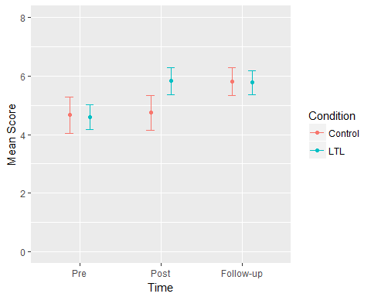
Figure 1: Mean Scores Across Time and Between Conditions (95% CIs)
Figure 1 shows that the mean score of test school participants increased from 4.59 points to 6.06 points, while the mean scores of the participants in the control group remained relatively unchanged, starting at 4.67 at baseline and then changing to 4.74 points at post. The results of the MLM indicated that this difference between pre and post mean change for the control and LTL conditions was statistically significant. As expected, the LTL group was associated with a statistically significant mean improvement points, while the control group was not. The model also considered the effect of previous public transport experience. The descriptive statistics for scores between groups and across time are reported in Table 10.

Table 10: Descriptive Statistics of Score by Time and Condition
Time | Condition | Min | Max | Mean | SD | n
Pre | Control | 1 | 7 | 4.67 | 1.57 | 27
 | LTL | 2 | 8 | 4.59 | 1.48 | 49
Post | Control | 0 | 7 | 4.74 | 1.51 | 27
 | LTL | 2 | 11 | 6.06 | 1.78 | 49
Follow-up | Control | 4 | 9 | 5.93 | 1.30 | 27
 | LTL | 2 | 8 | 5.78 | 1.45 | 49

Travel method by condition and type
We wanted to know if the impact of the education depended on students' familiarity with the public transport system. It might be that regular users of public transport to commute to school might not benefit as much from the Fines module when compared to students who usually get to school on a school bus. Alternatively, users of public transport for the school commute may benefit more from the program as they can better relate to the context of the modules.
For simplicity, and due to small samples sizes we combined participants who reported commuting to school by car, walking, riding and bus into a Non-public category. Figure 2 and Table 11 visualise and report the mean scores between conditions and regular travel methods across time, respectively. Figure 2 shows that the public transport users in the test schools improved the most on average scores on the post surveys and maintained this improvement in the follow-up surveys. Mean scores for public transport users in the control schools did not change much across time. The non-public transport commuters in the test schools followed a similar trend to participants who used public transport, albeit at a less pronounced improvement. However, for the non-public transport commuters in the control schools, there was a pronounced increase between post and follow-up time points. This surprising result is discussed in the next section. However, while participants who commuted to school on public transport appeared to gain the greatest benefit from the program, the effect was not considered statistically significant according to the MLM.

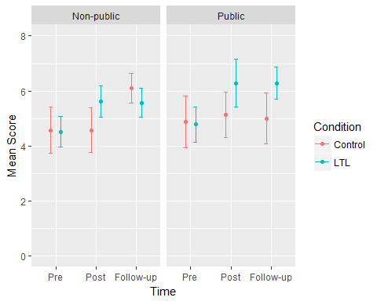
Figure 2: Mean Scores for Conditions and Travel Method Across Time (95% CIs)

Table 11: Descriptive Statistics of Score by Time, Condition and School
Public | Time | Condition | Min | Max | Mean | SD | n
Non-public | Pre | Control | 1 | 7 | 4.58 | 1.74 | 19
 | Pre | LTL | 2 | 8 | 4.51 | 1.62 | 35
 | Post | Control | 0 | 7 | 4.58 | 1.68 | 19
 | Post | LTL | 2 | 11 | 5.97 | 1.90 | 35
 | Follow-up | Control | 4 | 8 | 6.11 | 1.10 | 19
 | Follow-up | LTL | 2 | 8 | 5.57 | 1.56 | 35
Public | Pre | Control | 3 | 7 | 4.88 | 1.13 | 8
 | Pre | LTL | 3 | 6 | 4.79 | 1.12 | 14
 | Post | Control | 4 | 7 | 5.12 | 0.99 | 8
 | Post | LTL | 4 | 8 | 6.29 | 1.49 | 14
 | Follow-up | Control | 4 | 9 | 5.50 | 1.69 | 8
 | Follow-up | LTL | 5 | 8 | 6.29 | 0.99 | 14

Unanticipated result
An unanticipated outcome of the study was the improvement in the control group’s mean score at the third round follow-up interviews. Interestingly, the control group closed the gap by follow-up, significantly increasing its mean score to 5.93 points, while the LTL condition remained temporally stable at 5.78 points. By follow-up, both groups were no longer significantly different.
One possible explanation for the rebound effect in the control schools is that the control group participants talked with and shared knowledge with their peers about the interviews and research. This is plausible given the students' close interaction with each other. It's possible that word of mouth, reflection and discussion between peers, teachers and parents allowed students to informally learn the common rules about travelling on public transport by the time of the third interview.
However, a more likely explanation for the improvement among the control group was the ongoing connection with a lawyer placed in their school that students in school C had during the time the interviews took place. School C was participating in a Lawyer in Schools program run by WEstjustice, a local community legal centre (CLC). As part of this program a lawyer regularly visited school C to conduct community legal education sessions, as well as provide one-one-one legal information and advice to students experiencing legal problems. Coincidentally, this lawyer had spoken about fines and public transport at a school assembly in school C two days before we ran the third round follow-up interviews. The impact of this was noticeable to interviewers when asking participants whom they would go to for help if they were worried about getting a fine. Several participants said ‘my lawyer’ and a few named the lawyer who had been in the school.
Comparing the improvement among school C participants with the results from the other control participants in school D, which did not have a lawyer based in the school, would be the obvious next step in determining why school C showed such a strong improvement at follow-up without participants having been exposed to the Learning the law Fines module. However, school D had a smaller number of participants, so there was insufficient data for comparison.
The unexpected effect on school C participants can be linked to the Lawyer in School program. It suggests that this program has had a positive impact on a high-need audience. This early result could be further tested through follow-up interviews, using similar methodology. The statistical analysis supported the hypothesis that young people who participated in a class taught with the Learning the law Fines module showed a measurable improvement in their knowledge and understanding of legal issues associated with public transport and fines. Furthermore, this improvement remained four months after the participants’ learning experience.
Comments made by participants also suggested they felt more confident in dealing with legal issues and infringements associated with public transport and in seeking help if required. For example, in interviews before participants were taught a class using the Fines module, in response to the question, ‘Why do you think you need to have a myki or ticket to travel on public transport?’ some participants in the test group said things like, ‘Cos things aren't free these days’, and ‘You can't go riding around on things for free’. By the third round interviews, after receiving the class with the Fines module, we were consistently getting different answers to this question: ‘It’s against the law not to have a myki’, and ‘You will get in trouble by authorised officers if you don’t use myki’.
One young man emphasised his understanding by third round interviews when he answered the question, ‘Have you ever had any problems with your myki when travelling on public transport?’ with ‘No, I don't risk getting in trouble. I even carry two mykis just in case!’

Conclusion

Does Community legal education (CLE) work?
We set out to measure the impact of the Fines module for young people with mild intellectual disabilities. We wanted to know whether it improved their knowledge and understanding of laws on public transport and fines – in particular, understanding the importance of having the correct myki, having enough money on their myki and touching on and off properly when using public transport. The Learning the law program aims to educate young people to understand that taking these steps will help them avoid legal problems with public transport fines altogether.
While the Fines module was carefully planned and designed by VLA’s specialist CLE staff, with input from specialist school teachers and school principals, we could not rely on our own perception that the module was working. Demonstrating, through this research project, that a statistically significant improvement in young people’s knowledge and understanding of laws about public transport and fines occurred, is an important step in quantifying the value of community legal education in Australia, and in building a better understanding about what types of CLE are most effective, for whom and when.
Our aim to provide community legal education that helps prevent legal problems from arising, or to assist people when they have a legal problem, is furthered by this research which helps us understand the impact of our work and enables us to further target, refine and improve our CLE strategies for harder to reach audiences.

Future considerations
We are at the beginning of building evidence in Australia of the impact of community legal education and of evaluating and measuring what works and what doesn’t. Every attempt to evaluate our work – small or large – matters and we know that with limited resources and increasing demands, we cannot conduct large scale research for every CLE project.
The unexpected effect on school C participants in this study, which indicates that community legal education can have a significant impact on high need audiences suggests that there would be value in further, targeted research in this area, possibly by legal assistance sector organisations in partnership with universities.

Distribution of this report
Parents, teachers and school staff will be provided with the final report that will also be published on VLA's website.
We produced an accessible report in the form of a thank-you card for participants (see Appendix F) to explain the research outcomes and the value of their participation. VLA provided this to participating schools at the conclusion of the study.
The report will be distributed to the legal assistance and community sectors via the CLE newsletter and VLA social media channels as appropriate.
This report will be adapted into an academic paper for publication in 2018-2019.

Appendices
Appendix A: Information sheet and consent forms for parents and participants
Appendix B: Pre survey
Appendix C: Post and follow up survey
Appendix D: RMIT report
Appendix E: Ethics approval
Appendix F: Accessible reports for participants

Appendix A

Information sheet for parents and guardians about Victoria Legal Aid’s research
March 2016
Do you need this information in a different format? Please phone us on (03) 9269 0439 to talk with us about what you need.

Victoria Legal Aid would like to invite your child to be part of some research.
The research is about whether legal education helps young people.
Victoria Legal Aid and the Department of Education and Training have produced a free online education kit called Learning the law to help young people understand information about legal issues to do with fines. The research will show us if the education kit really helps young people to understand.
Victoria Legal Aid would like to invite your child to be part of the research. We will only do this if you give permission.

What would my child have to do as part of the research?
Being part of the research would mean that your child speaks with a Victoria Legal Aid staff members and answers some questions.
We will ask your child questions three times in interviews – for about 30 minutes each time.
Interviews will be held at school.
All Victoria Legal Aid staff doing the interviews will have Working With Children cards and have experience working with participants who may have challenges understanding information.
Interviews will be relaxed and informal and interviewers will take as much time as needed to make sure your child understands what is being asked.
Your child can choose to have a support person in the interviews.

How do I give permission?
Sign the consent form that came with this information sheet to say that:
- you agree that your child can be part of the research
- your child can be interviewed three times by Victoria Legal Aid staff at school.
If you give permission, we will also ask your child for his or her permission at each interview.

Can I change my mind after I have given permission?
Yes, you can decide that your child will stop being part of the research at any time just by telling us.
Your child can also choose to stop being part of the research at any time.
We will not use information we get from your child if you or your child decide to stop being part of the research.

Will information from the research be used for assessment by the school?
No. School staff and your child’s teachers will not be part of the research and will not see your child’s answers from the interviews or use them for assessment.

How will my child’s information be used?
We will write a research report that will be published on Victoria Legal Aid's website.
We send our research report and a summary to your child’s school and ask them to pass these on to you. We will also publish a summary in a suitable format for your child, using images and send this to the school.
Your child’s name and any private information he or she tells us will not be in the report or the summaries.

Where will information be kept?
All information collected will be stored securely by Victoria Legal Aid’s office at 350 Queen Street, Melbourne VIC 3056.

How long will information be kept for?
We will store your child’s first name, date of birth and gender while we are doing the three interviews so that we can make sure we are interviewing the right person each time. We will destroy this personal information within two weeks after the last interview.
We will protect your child’s privacy and will make sure any personal information your child gives us cannot be identified by anyone except Victoria Legal Aid staff involved in the research.
We will remove any personal or identifying information when we publish reports about our research.

What if I have more questions?
If you have any questions, at any time before, during or after the research, you can speak with the associate researcher: Allyson Hose from Victoria Legal Aid on 9269 0439.

What if I need to make a complaint?
If you have any complaints or concerns about any aspect of the research, you can speak with Victoria Legal Aid’s Complaints and Statutory Compliance team on 9280 3789.

Consent form for parents and guardians

March 2016

Victoria Legal Aid’s research

I agree to allow my child to be part of Victoria Legal Aid’s research project for their Learning the law kit.

- I have read the attached information sheet, and have kept a copy. I understand that:

- My child’s participation in the research is voluntary. My child does not have to answer questions and can choose to leave and return to class or to stop being part of the study any time.

- Victoria Legal Aid will protect my child’s privacy and will not publish any identifying or personal information my child gives them.

- I can ask questions about study at any time by contacting associate researcher Allyson Hose on 9269 0439, or allyson.hose@vla.vic.gov.au

- The research may be used by Victoria Legal Aid to improve their publications and services.

- If I have any complaints or concerns at any time, I can speak with Victoria Legal Aid’s Complaints and Statutory Compliance team on 9280 3789.

Student’s name: ……………………………………………………………………………………………………………………

Parent or guardian’s name: ……………………………………………………………………………………………………………………

Parent or guardian’s signature: ……………………………………………………………………………………………………………………

Date: ……………………………………………………………………………………………………………………

Information sheet for participants

March 2016

Victoria Legal Aid’s research

What is the research about?
The research is about whether legal education helps young people.

What do I have to do to be part of the research?
Being part of the research will mean chatting to us and answering some questions.
We will ask you questions three times in interviews – for about 30 minutes each time.
You can choose to have a support person with you in the interviews.

How do I say yes?
Sign a consent form and ask your parent or guardian to sign a consent form to say that:
- you want to be part of the research
- you can come to three interviews.
Think about if you want to be part of the research. Talk to your parents, your teacher and your friends about it if you like.

Can I change my mind about being part of the research?
Yes, you can decide to stop being part of the research any time just by telling us. You can stop during any of the interviews if you want to.
We will not use information about you in our report if you decide to stop helping.

Will being part of the research affect my marks at school?
No. The research is not part of what happens at school and your teacher will not be at the interview or see your answers.
Being part of the research, or choosing to stop, will not affect anything else that happens at school and your teacher will not give you a mark for it

How will my information be used?
We will write a report that will be published on legal aid's website.
We will also make a summary in a similar style to this information sheet and send it to you.
Your name and any private information you tell us will not be in the report or the summary.

What are the good things about helping out?
The research will tell us if legal education helps young people
We will use what you tell us to make our information better for other young people.

What if I have more questions?
If you have any questions about the research please call Allyson Hose on 9269 0439.
You can call any time.

What if I need to make a complaint?
Please tell us if you want to stop being part of the research or if you are not happy with anything that happens during the research.
It is ok to make a complaint if you want to.
You can make a complaint by calling legal aid on:
9280 3789

Consent form for participants

March 2016

Victoria Legal Aid’s research
Victoria Legal Aid have asked me to be part of some research about whether legal education helps young people. I understand that:
- I can choose whether to be part of the research – I do not have to.
- I can decide to stop being part of the research any time and legal aid will not use any information I give them
- Being part of the research will not affect anything else that happens at school and my teacher will not give me a mark for it
- I can ask questions any time
- I can make a complaint any time if I’m not happy with anything that happens during the research.
Knowing all of this:
- yes, I choose to be part of the research
- no, I prefer not to be part of the research

Name: ______________________________________

Signature:____________________________________

Appendix B

Evaluation of Victoria Legal Aid's 'Learning the law' education kit

Pre education delivery survey

August 2016

Notes for researchers
The following survey questions are designed to be asked as informally as possible, in the context of a conversation with the participant. There are 13 key questions (in bold) and these are the most important to get answers to, if you can. It would be great to also get answers to the prompt questions (in blue) below some of the 13 key questions, however, the prompt questions are less of a priority.
Recording a participant’s answers
Please write down the participant’s answer to each question in the comment box provided. Please record the answer as accurately as possible, using the language the participant uses.
Before you begin the interview
- Introduce yourself, tell the student why you are there, for example,
‘Hi, my name is _______ and I am here to ask you some questions about travelling on trains and trams. Your parents have said it is ok for you to talk to us but I want to check that you are happy to talk to us? You don’t have to, if you don’t feel like it’.
- Ensure that you have the signed consent form from the participant’s parent or guardian (note the interview cannot start without this). If you do not have a consent form from the parent or guardian say:
‘thanks for talking to me but I need to get a form from your parents first, to make sure they are happy for us to talk to you some more’.
- If you don’t have a consent form, say:

‘that’s ok it was nice to meet you. Would you like me to walk you back to your class?’

- If you have a consent form from the student’s parent or guardian, you can then determine if the student is happy to provide their consent. Suggest asking:
‘Are you happy to talk to me today?’
If so:
‘Before we start I need to go through a form with you. The form says that you are happy to talk to me. It’s called a consent form’. If you are ok with what the form says then you can sign it. You don’t have to sign it.
- Go through the consent form with the participant and use this checklist to make check that they understand that:
- they don’t have to answer questions if they don’t want to, and can leave and return to class at any time if they decide not to participate
- their participation is not linked to anything else they do at school – they won’t be marked on it and their teacher won’t see their answers
- what they say is confidential. We are writing down the information they give us but their names won’t be used when we write about the results of our research
- we will report back at the end of the research to let them know what we find
- we can help them to talk to a lawyer about any legal problems they might tell us about, if need be.

Survey
Note the following details about the participant (you can ask their name and age informally in your initial conversation).
Full name: _______________ ____________________
Date of birth: ____________________
Gender
- female
- male
Note: Please encourage participants to take their time answering these questions. Tell them that there are no right or wrong answers. They can ask for clarification if there’s anything they don’t understand. You may need to repeat the questions for some participants.
1. How do you get to school most days?
Note that if the participant says ‘bus’, please clarify whether it is a school bus (private) or a public bus (where they need to use a myki or ticket).

2. Only ask this question if the participant said that they get to school on public transport (tram, train, public bus) at question 1. If the student does not use public transport but walks, rides a bike, or travels to school by car or a privately run school bus, go straight to question 3.
Do you travel to school with an older person who helps you (such as a brother or sister, or an adult who travels with you)?
This question aims to determine whether the participant travels independently. Many participants will be familiar with this term, so you can ask if they travel independently if their answer to question 2 is unclear.

3. Do you think you need to have a myki or ticket to travel on public transport?

4. Only ask this if the participant answered ‘yes’ to question 3. If the student said they don’t need a ticket, go straight to question 5.
Why do you think you need to have a myki or ticket to travel on public transport?

5. What do you think might happen if you travel on public transport without a myki or ticket?

6. Have you ever had any problems with your myki when travelling on public transport?
If the participant answered ‘yes’ to this question please ask them what kind of trouble – for example, trouble with machines not working, trouble with Authorised Officers, or some other problem.

7. Only ask this if the participant answered ‘yes’ to question 6. If the student said they have not had problems with myki, go straight to question 8.
Can you tell me what happened?
– Can you tell me what happened when you had a problem?
– Can you tell me a bit about how you felt when the problem started?
– What did you do about this problem?

8. Have you ever spoken to an Authorised Officer on a train, bus, tram or at a station?
Note that it’s fine to explain that Authorised Officer means ‘ticket inspector’ if the participant seems confused by the term. Please do ask the question first using ‘Authorised Officer’ though as this is the term we will use when reporting on the data.

If the participant answered ‘yes’ to this question please ask them to be as specific as possible about the details: ask when they spoke to the Authorised Officer, and what the circumstances were – what happened?

9. What would you do if you got to a train station and discovered that you have left your myki or ticket at home?

10. Imagine that your friend got a fine because he/she did not have enough money on their myki. Your friend asks you what he/she should do. What would you say?

11. Who would you talk to if you were ever worried about getting a fine?

12. Do you know of any other places you can go to, or people you can call for help, if you are worried about fines?
If the participant says yes, ask if they can name a service (such as legal aid or Kids’ Helpline) and ask them if they have the number, or where they would get the number, and where they would phone from. We want to find out if the participant has enough knowledge to potentially take action.

13. What does the law say, or what are some rules you need to know, when you’re at a train station or travelling on a train, tram or bus?
Ask the participant to list all the things they can remember about what the law says

At the end of the interview:
- Thank the participant for taking part in the research and make sure that they know where to go next (i.e. back to class).
- Remind them that they have our phone number on their information sheet and can call us any time if they have any questions.
- If appropriate, offer to go with them and walk them back to class.

Appendix C

Evaluation of Victoria Legal Aid's 'Learning the law' education kit

Post and follow up education delivery survey

September 2016

Notes for researchers
The following survey questions are designed to be asked as informally as possible, in the context of a conversation with the participant. There are 13 key questions (in bold) and these are the most important to get answers to, if you can. It would be great to also get answers to the prompt questions (in blue) below some of the 13 key questions, however, the prompt questions are less of a priority.
Recording a participant’s answers
Please write down the participant’s answer to each question in the comment box provided. Please record the answer as accurately as possible, using the language the participant uses.
Before you begin the interview
- Introduce yourself, tell the student why you are there, for example,
‘Hi, my name is _______ and I am here to ask you some questions about travelling on trains and trams. We want to check that you are happy to talk to us? You don’t have to, if you don’t feel like it’.
- Remind the participant that they signed a consent form at the first interview, but that it is ok to change their mind about participating at any time. Use this checklist to check that they remember and understand that:
- they don’t have to answer questions if they don’t want to, and can leave and return to class at any time if they decide not to participate
- their participation is not linked to anything else they do at school – they won’t be marked on it and their teacher won’t see their answers
- what they say is confidential. We are writing down the information they give us but their names won’t be used when we write about the results of our research
- we will report back at the end of the research to let them know what we find
- we can help them to talk to a lawyer about any legal problems they might tell us about, if need be.

Survey
Note the following details about the participant (you can ask their name and age informally in your initial conversation).
Full name: _______________ ____________________
Date of birth: ____________________
Gender
- female
- male
Note: Please encourage participants to take their time answering these questions. Tell them that there are no right or wrong answers. They can ask for clarification if there’s anything they don’t understand. You may need to repeat the questions for some participants.
1. How do you get to school most days?
Note that if the participant says ‘bus’, please clarify whether it is a school bus (private) or a public bus (where they need to use a myki or ticket).

2. Only ask this question if the participant said that they get to school on public transport (tram, train, public bus) at question 1. If the student does not use public transport but walks, rides a bike, or travels to school by car or a privately run school bus, go straight to question 3.
Do you travel to school with an older person who helps you (such as a brother or sister, or an adult who travels with you)?
This question aims to determine whether the participant travels independently. Many participants will be familiar with this term, so you can ask if they travel independently if their answer to question 2 is unclear.

3. Do you think you need to have a myki or ticket to travel on public transport?
- yes
- no

4. Only ask this If the participant answered ‘yes’ to question 3. If the student said they don’t need a ticket, go straight to question 5.
Why do you think you need to have a myki or ticket to travel on public transport?

5. What do you think might happen if you travel on public transport without a myki or ticket?

6. Have you ever had any problems with your myki when travelling on public transport?
If the participant answered ‘yes’ to this question please ask them what kind of trouble – for example, trouble with machines not working, trouble with Authorised Officers, or some other problem.

7. Only ask this if the participant answered ‘yes’ to question 6. If the student said they have not had problems with myki, go straight to question 8.
Can you tell me what happened?
– Can you tell me what happened when you had a problem?
– Can you tell me a bit about how you felt when the problem started?
– What did you do about this problem?

8. Have you ever spoken to an Authorised Officer on a train, bus, tram or at a station?
Note that it’s fine to explain that Authorised Officer means ‘ticket inspector’ if the participant seems confused by the term. Please do ask the question first using ‘Authorised Officer’ though as this is the term we will use when reporting on the data.

If the participant answered ‘yes’ to this question please ask them to be as specific as possible about the details: ask when they spoke to the Authorised Officer, and what the circumstances were – what happened?

9. What would you do if you got to a train station and discovered that you have left your myki or ticket at home?

10. Imagine that your friend got a fine because he/she did not have enough money on their myki. Your friend asks you what he/she should do. What would you say?

11. Who would you talk to if you were ever worried about getting a fine?

12. Do you know of any other places you can go to, or people you can call for help, if you are worried about fines?
If the participant says yes, ask if they can name a service (such as legal aid or Kids’ Helpline) and ask them if they have the number, or where they would get the number, and where they would phone from. We want to find out if the participant has enough knowledge to potentially take action.

13. What does the law say, or what are some rules you need to know, when you’re at a train station or travelling on a train, tram or bus?
Ask the participant to list all the things they can remember about what the law says.

At the end of the interview:
- Thank the participant for taking part in the research and make sure that they know where to go next (i.e. back to class).
- Remind them that they have our phone number on their information sheet and can call us any time if they have any questions.
- If appropriate, offer to go with them and walk them back to class.

Appendix D
Evaluation of Victoria Legal Aid's 'Learning the Law' Education Kit
Dr James Baglin, School of Sciences, Mathematical Science, RMIT University
Last updated: 28/04/2017
Table of Contents
Summary 35
Method 36
Sample 36
Measures 36
Design 39
Analysis and Results 39
Data Preparation 39
Sample Characteritics 39
Visualisation and Description 41
Time by Condition 41
School by Time 42
Travel Method by Condition and Time 43
Modelling 45
Model Interpretation 45
Discussion 47

Summary
Victoria Legal Aid's (VLA) Community Legal Education (CLE) team led the evaluation of the the Fines and Driving module of the online Learning the Law (LTL) tool. Specifically, this evaluation relates to the Fine topics within the module. LTL is a suite of online teacher tools (teacher resource documents, videos and online modules) developed for students with mild intellectual disabilities in years 8 to 12. LTL aims to minimise legal issues of populations deemed to be at high risk through targeted education. LTL has been designed to educate students about their legal responsibilities and rights relating to fines in a simplified and accessible manner.
- In 2016, the CLE team initiated an evaluation of the program and contracted Dr James Baglin, RMIT University, to assist with the evaluation design and analysis. This project built upon a previous CLE evaluation completed by Monica Ferrari, Manager, Community Legal Education, which evaluated the What's the law? Australian law for new arrivals video resources in 2013. Ferrari's evaluation found statistically significant increases in participants' knowledge of the legal issues around the purchase of a car following the completion of a What's the law module. Ferrari's thesis can be accessed via the RMIT Research Bank and a journal publication summarising the main findings is forthcoming.
- The evaluation surveyed students' knowledge of public transport fines at three different times point (pre, post and follow-up) in four Victorian special needs schools. Ethics clearance from the Justice Human Research Ethics Committee (JHREC) and approval from the Victorian Department of Education and Training and School Principals was sought prior to data collection. Pre education surveys were administered in face-to-face interviews by members of the CLE team one week prior to the delivery of LTL Fines module. In the following week, the LTL Fines topic was delivered in class by teachers The CLE team conducted follow-up interviews using the same key questions used to assess knowledge of fines gained from the LTL module two weeks later. The CLE returned again four months post follow-up to survey the students one more time in order to evaluate long-term retention of learning.

Method

Sample
The CLE team interviewed a total of 104 students from four special schools in Melbourne, Victoria, which have been de-identified as school "A", "B", "C" and "D". However, this total dropped to 76 by the follow-up interviews, which meant that 28 dropped out or opted-out. The majority of drop-out occurred in School D.

Measures
The survey was administered three times (pre, post and follow-up) during interviews by the CLE team with students who consented to participating in the evaluation. The survey contained thirteen questions that were repeated across the three interviews. The first two questions related to students' regular method of travel to school (Q1) and whether they were typically accompanied by an older person (e.g. older sibling or guardian)(Q2). Questions 3 - 5 and 9 - 13 related to students' understanding of public transport fines. These questions were aligned to the learning outcomes of the LTL Fines topic. Question 6 - 8 asked students whether they had experienced problems on public transport (Q6), to elaborate on Q6 if required and whether they had spoken to an authorised officer (Q8). Therefore, questions 1 - 2, and 6 - 8, were not included in the construction of a knowledge score.
- Questions 3 - 5 and 9 - 13 (scoring items) were scored blindly by members of the CLE team and cross-checked by independent scorers (these scorers were not part of the CLE team). Score discrepancies were settled by the CLE team leaders, who were also blind to the participants' details during scoring. This meant that all scoring was done without knowledge of whether a student was in the LTL or control condition. This was done to reduce the risk of evaluator bias.
- Pre responses to Question 1 and 2 were an important control variable to be included in the analysis. If a student regularly travelled on public transport and with an older sibling or adult, they may already have knowledge of public transport rules and fines. Therefore, it was possible that the effect of LTL Fine module would be moderated when compared to a student that did not travel to school via public transport. In situations where students caught multiple forms of transport including both private (school bus and/or car) and public, their transport method was recorded as public. This is because these students would still be exposed to public transport rules. Some students commented that they used public transport on weekends, but this was reported haphazardly and could not be consistently coded for all responses.
- The thirteen questions and their respective coding are detailed below.
- How do you get to school most days?
  - Car/Walk/Ride
  - School Bus
  - Public (Bus, Tram or Train)
- Do you travel to school with an older person who helps you (such as a brother or sister, or an adult who travels with you)?
  - Yes, if a student took public transport with an older person
  - Otherwise, no.
- Do you think you need to have a myki or ticket to travel on public transport?
  - No = 0 points
  - Yes = 1 point
- Why do you think you need to have a myki or ticket to travel on public transport?
  - 0 points if there is no answer or if the answer includes things like:
    - because public transport needs to make money
    - so I can get to a particular place
    - so you can get on to the bus/get in to the station
  - Give 1 point if the answer includes any of the following (similar wording is ok):
    - if you don’t you could get in trouble
    - you have to pay for public transport
    - there are ticket inspectors/Authorised Officers, plus
  - Give 1 point if the answer includes any of the following (similar wording is ok):
    - you have to have valid myki
    - it’s against the law not to have your myki
    - you could get a fine
- What do you think might happen if you travel on public transport without a myki or ticket?
  - Give 0 points if there is no answer or if the answer includes things like:
    - you won’t be allowed on the bus/train/tram
  - Give 1 point if the answer includes any of the following (similar wording is ok):
    - you could get in trouble (including you could get kicked off / ‘they’ could make you get off)
    - you might get caught by the ticket inspectors/Authorised Officers
    - you could get a fine
- Have you ever had any problems with your myki when travelling on public transport?
  - No score for this question
- Only ask this if the participant answered ‘yes’ to question 6. If the student said they have not had problems with myki, go straight to question 8. Can you tell me what happened?
  - No score for this question
- Have you ever spoken to an Authorised Officer on a train, bus tram or at a station?
  - No score for this question
- What would you do if you got to a train station and discovered that you have left your myki or ticket at home?
  - Give 0 points if the answer indicates that the participant would try to travel without the myki.
  - Give 1 point if the answer indicates that the participant would not try to travel without the myki but would try to get a myki or get help – responses such as:
    - I’d tell the ticket inspector or talk to a person who works at the station
    - I’d ring a parent
    - I’d go home and get my card.
- Imagine that your friend got a fine because he/she did not have enough money on their myki. Your friend asks you what he/she should do. What would you say?
  - Give 0 points if the answer indicates that the participant wouldn’t offer the friend any realistic suggestions about dealing with the fine, such as:
    - answers that just focus on the rule that you have to have money on or top up the myki
    - answers that say the participant would give their friend money or offer to pay the fine for them
    - answers like: talk to an authorised officer, the police, or public transport staff.
  - Give 1 point if the answer indicates that the participant would tell their friend to ‘get help’ or tell a trusted adult (such as a parent, carer or teacher) or an organisation or agency (such as legal aid, kids helpline, other valid community organisation). plus
  - Give 1 point if the answer indicates that the participant understands some of the consequences of being caught travelling without a myki and tells their friend about them, such as:
    - you’ll have to pay the fine (or pay it off in instalments)
    - you may have to go to court if you don’t pay the fine
- Who would you talk to if you were ever worried about getting a fine?
  - Give 0 points if there is no answer or answers like: an authorised officer, the police, or public transport staff.
  - Give 1 point of the answer includes a trusted adult (parent, teacher, carer older sibling etc) or an organisation or agency (such as legal aid, kids helpline, other valid community organisation).
- Do you know of any other places you can go to, or people you can call for help, if you are worried about fines?
  - Give 0 points if there is no answer or if the answer includes family members or other trusted adults the participant may know personally but who’re not listed in question 11 (for example, if they’ve answered ‘Mum’ in question 11 and ‘my teacher’ in question 12)
  - Give 0 points for answers like: an authorised officer, the police, or public transport staff.
  - Give 1 point of the answer includes an organisation or agency (such as legal aid, kids helpline, other valid community organisation) or if they say they’d speak to a lawyer
- What does the law say, or what are some rules you need to know, when you’re at a train station or travelling on a train, tram or bus?
  - Give 0 points for answers that only include behavioural things like: don’t put your feet on the seats, no graffiti, no swearing, stand behind the yellow line etc.
  - Give 1 point for each mention of any of the following (similar wording is ok):
    - you must have a valid myki card to travel
    - you must have enough money on your myki
    - you must touch on
    - Authorised Officers can ask to check your myki and concession card
    - Authorised Officers are supposed to treat people with respect and cannot harass, be too forceful or discriminate against people, and you can complain if that happens.
The scored questions, 3 - 5 and 9 - 13, were summed together to create a total score for each participant at each time point. Scores could range from 0 - 14 points. High scores were assumed to represent a student who was well informed about public transport law.

Design
The evaluation was a quasi experimental design (treatment and wait list-control) with repeated measures (pre, post and follow-up). Two schools recruited in the evaluation implemented the LTL Fines module, while the other two schools acted as a wait-list control. The other two schools were required to wait until after the follow-up period before implementing the LTL Fines module. This provided a valuable basis for comparison to the students in the LT condition.

Analysis and Results

Data Preparation
The data was provided in Excel format by the VLA CLE team. The data were imported into R, variable names were simplified and left-over white space removed in some columns. Factors were also defined for the School (A, B, C, D), Condition (Control, LTL), Time (Pre, Post, Follow-up), Gender, School Travel Method (Car/Walk/Ride, Public, School Bus) and Travel Companion (Yes, No) variables. The original dataset was in a long format with each participant having three rows referring to pre, post and follow-up data.
- A dataset containing only the participant's characteristics during the time of the pre-interview was also created. This dataset of unique participants was used to explore the characteristics of the sample.

Sample Characteritics
The following sections report the characteristics of the sample. A total of 49 participants from Schools A and B completed the LTL Fines module and responded to each of the three surveys (pre, post and follow-up)(Table 1). In the Control condition there was a total 27 participants, with only 3 coming from school D. School D was under-represented and this should be noted as a limitation. As such, School D observations were combined into a "School C and D" grouping.
Table 1: Distribution of Participants by School and Condition
 | School A | School B | School C | School D | Sum
Control | 0 | 0 | 24 | 3 | 27
LTL | 30 | 19 | 0 | 0 | 49
Sum | 30 | 19 | 24 | 3 | 76
- Table 2 reports the sample characteristics by condition and gender. Both conditions were dominated by males.
Table 2: Distribution of Participants by Condition and Gender
Condition | Gender | n | Proportion
Control | Female | 7 | 0.26
Control | Male | 20 | 0.74
LTL | Female | 17 | 0.35
LTL | Male | 32 | 0.65
- Table 3 and Table 4 reports the sample characteristics by condition and age. Fourteen and fifteen year old students were the most frequent in both conditions.
Table 3: Frequency Distribution of Participants by Condition and Age
 | 12 | 13 | 14 | 15 | 16 | 17 | 18 | Sum
Control | 0 | 2 | 8 | 9 | 2 | 2 | 0 | 23
LTL | 1 | 5 | 14 | 14 | 8 | 5 | 1 | 48
Sum | 1 | 7 | 22 | 23 | 10 | 7 | 1 | 71
Table 4: Proportional Distribution of Participants by Condition and Age
 | 12 | 13 | 14 | 15 | 16 | 17 | 18
Control | 0.00 | 0.09 | 0.35 | 0.39 | 0.09 | 0.09 | 0.00
LTL | 0.02 | 0.10 | 0.29 | 0.29 | 0.17 | 0.10 | 0.02
- Table 5 and Table 6 reports the distribution of school travel method by condition. The proportion of students that used public transport was similar across conditions.
Table 5: Frequency Distribution of Participants by Condition and School Travel Method
 | Car/Walk/Ride | Public | School Bus | Sum
Control | 7 | 8 | 12 | 27
LTL | 4 | 14 | 31 | 49
Sum | 11 | 22 | 43 | 76
Table 6: Proportional Distribution of Participants by Condition and School Travel Method
 | Car/Walk/Ride | Public | School Bus
Control | 0.26 | 0.30 | 0.44
LTL | 0.08 | 0.29 | 0.63
- Table 7 and Table 8 displays the number of participants that reported travelling with a companion whilst commuting to school on public transport. As there was only one participant that was found to fit this category, this variable was not included in subsequent analysis.
Table 7: Frequency Distribution of Participants by Condition and Travel Companion Categories
 | No | Yes | Sum
Control | 27 | 0 | 27
LTL | 48 | 1 | 49
Sum | 75 | 1 | 76
Table 8: Proportional Distribution of Participants by Condition and Travel Companion Categories
 | No | Yes
Control | 1.00 | 0.00
LTL | 0.98 | 0.02

Visualisation and Description

Time by Condition
Figure 1 shows the mean scores (depicted as points) across time and condition. The error bars (lines extending above and below each mean) represent 95% CIs of the mean. Confidence intervals give an indication of how much uncertainty surrounds mean. The wider the intervals, the greater the uncertainty. When CIs from independent groups overlap to a high degree, there is unlikely to be significant differences between groups (e.g. between scores for the LTL and control condition at pre and follow-up). However, when CIs do not overlap, significant differences are likely (e.g. between the LTL and control condition at post).
- Figure 1: Mean Scores Across Time and Between Conditions (95% CIs)
- In Figure 1, mean pre scores between conditions are almost equal, but at post, the LTL group outperforms the control condition, which didn't improve from baseline. By follow-up, the LTL condition appears to maintain its mean gain, but, interestingly, the control condition catches up. The descriptive statistics for scores between groups and across time are reported in Table 10.
Table 10: Descriptive Statistics of Score by Time and Condition
Time | Condition | Min | Max | Mean | SD | n
Pre | Control | 1 | 7 | 4.67 | 1.57 | 27
Pre | LTL | 2 | 8 | 4.59 | 1.48 | 49
Post | Control | 0 | 7 | 4.74 | 1.51 | 27
Post | LTL | 2 | 11 | 6.06 | 1.78 | 49
Follow-up | Control | 4 | 9 | 5.93 | 1.30 | 27
Follow-up | LTL | 2 | 8 | 5.78 | 1.45 | 49

School by Time
In order to rule out a possible school interaction for the LTL condition, Figure 2 visualises mean scores by condition and school. According to Figure 2, the trend for School A and B was consistent, which suggested that no consideration of an interaction effect for school was needed during modelling. Table 11 reports the descriptive statistics for score between schools and across time.
- 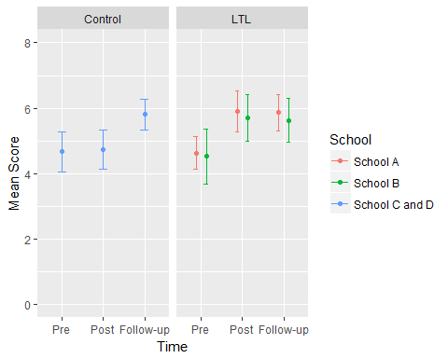 Figure 2: Mean Scores Across Time and Between Conditions and Schools (95% CIs)
Table 15: Descriptive Statistics of Score by Public Commute, Time and Condition
School | Time | Min | Max | Mean | SD | n
School A | Pre | 2 | 7 | 4.63 | 1.33 | 30
School A | Post | 2 | 9 | 6.00 | 1.72 | 30
School A | Follow-up | 2 | 8 | 5.87 | 1.50 | 30
School B | Pre | 2 | 8 | 4.53 | 1.74 | 19
School B | Post | 4 | 11 | 6.16 | 1.92 | 19
School B | Follow-up | 3 | 8 | 5.63 | 1.38 | 19
School C and D | Pre | 1 | 7 | 4.67 | 1.57 | 27
School C and D | Post | 0 | 7 | 4.74 | 1.51 | 27
School C and D | Follow-up | 4 | 9 | 5.93 | 1.30 | 27

Travel Method by Condition and Time
The next question was whether students' familiarity with public transport interacted with the effectiveness of the LTL module. In other words, did the impact of the LTL module depend on students' familiarity with the public transport system? It might be that regular users of public transport to commute to school might not benefit as much from the LTL module when compared to students who typically travel to school on a school bus, independent or with a parent. Alternatively, users of public transport for the school commute may benefit more from the program as they can better relate to the context of the modules.
- For simplicity, and due to small samples sizes in the "Car/Walk/Ride" level of the travel method factor, the "Car/Walk/Ride" and "School Bus" levels were combined into a "Non-public" level. Figure 3 and Table 12 visualises and reports the mean scores between conditions and regular travel methods across time, respectively. A possible interaction effect was present. Participants who commuted to school on public transport appeared to gain the greatest benefit from the program.
- Figure 3: Mean Scores for Conditions and Travel Method Across Time (95% CIs)
Table 11: Descriptive Statistics of Score by Time, Condition and School
Public | Time | Condition | Min | Max | Mean | SD | n
Non-public | Pre | Control | 1 | 7 | 4.58 | 1.74 | 19
Non-public | Pre | LTL | 2 | 8 | 4.51 | 1.62 | 35
Non-public | Post | Control | 0 | 7 | 4.58 | 1.68 | 19
Non-public | Post | LTL | 2 | 11 | 5.97 | 1.90 | 35
Non-public | Follow-up | Control | 4 | 8 | 6.11 | 1.10 | 19
Non-public | Follow-up | LTL | 2 | 8 | 5.57 | 1.56 | 35
Public | Pre | Control | 3 | 7 | 4.88 | 1.13 | 8
Public | Pre | LTL | 3 | 6 | 4.79 | 1.12 | 14
Public | Post | Control | 4 | 7 | 5.12 | 0.99 | 8
Public | Post | LTL | 4 | 8 | 6.29 | 1.49 | 14
Public | Follow-up | Control | 4 | 9 | 5.50 | 1.69 | 8
Public | Follow-up | LTL | 5 | 8 | 6.29 | 0.99 | 14
- Figure 3 indicated that the public transport users in the LTL condition improved the most on average scores on the post surveys and maintained this improvement in the follow-up surveys. Mean scores for public transport users in the control condition did not change much across time. The non-public transport commuters in the LTL condition followed a similar trend to their public commuter counterparts, albeit at a less pronounced improvement. However, for the non-public transport commuters in the control condition, there was a pronounced increase between post and follow-up time points.

Modelling
Statistical modelling was performed to test for a statistically significant improvement in scores following the LTL module. Based on the previous visual inspection of the data, it was apparent that time and public transport commute might pose possible interactive effects. This meant that when considering the difference between the conditions on mean scores, it was important to consider the time point and participants' school commute method in the statistical models.
- In order to understand if the effect of the LTL modules and the interactions with public transport commuting and time were statistically significant, linear multilevel modelling (MLM) was performed. The MLM model was specified to predict mean score using condition, time and public school commute as predictors. Two and three-way interactions between condition, time and public commute were also considered. Scores were nested within participants. The model included two between-group factors, condition, which had two levels (control and LTL) and public, which had two levels (public and non-public) and one repeated measures factor, Time, which had three levels (pre, post and follow-up).
- Model building proceeded by starting with a baseline model and adding each main effect, two-way and three-way interaction in turn. The highest order statistically significant model was selected for interpretation. Table 13 indicates that the model including up to a two-way interaction between time and condition was the best model. Therefore, this model was interpreted in detail in the following sections.
Table 13: MLM Model Comparisons
Model | df | AIC | BIC | LogLik | Test | L.Ratio | p.value
Baseline | 4 | 854.510 | 868.227 | -423.255 |  | NA | NA
Time | 6 | 816.547 | 837.123 | -402.274 | 1 vs 2 | 41.962 | 0.000
Time and Condition | 7 | 817.065 | 841.070 | -401.532 | 2 vs 3 | 1.483 | 0.223
Time, Condition, Public | 8 | 818.116 | 845.551 | -401.058 | 3 vs 4 | 0.948 | 0.330
Time:Condition | 10 | 802.447 | 836.740 | -391.223 | 4 vs 5 | 19.670 | 0.000
Time:Public | 12 | 806.260 | 847.412 | -391.130 | 5 vs 6 | 0.187 | 0.911
Condition:Public | 13 | 807.964 | 852.545 | -390.982 | 6 vs 7 | 0.296 | 0.586
Time:Condition:Public | 15 | 807.398 | 858.838 | -388.699 | 7 vs 8 | 4.566 | 0.102

Model Interpretation
The Table 14 output below summarises the multilevel model testing the effect of public commuting and condition on mean score across time. The model included two statistically significant main effects for the time contrasts. Contrast one, which compared pre mean scores to post mean scores, $b=-0.37,t(148)=-2.18,p=0.03$, was statistically significant. Contrast two, which compared pre to follow-up mean scores, was also statistically significant, $b=0.81,t(148)=4.79,p<.001$. The main effects for Condition, $b=0.37,t(73)=1.22,p=.225$ and Public commuting, $b=0.305,t(73)=0.96,p=0.339$ were not statistically significant. Because the higher order interactions were also statistically significant, our interpretation of the model parameters will focus on these interactions.
- The results of the model confirm the story presented back in Figure 1. Between pre and post survey times, the LTL condition scored significantly higher on average than the control condition, $b=0.96,t(148)=4.51,p<.001$. However, when comparing pre to follow-up survey scores, the control condition significantly closed the gap, $b=-0.52,t(148)=-2.43,p=.016$. This rebound effect for the control group was a interesting finding.
## Linear mixed-effects model fit by maximum likelihood
## Data: vladf
## AIC BIC logLik
## 802.4467 836.7402 -391.2234
##
## Random effects:
## Formula: ~1 | ID
## (Intercept)
## StdDev: 1.07301
##
## Formula: ~1 | Time %in% ID
## (Intercept) Residual
## StdDev: 0.9767137 0.4283076
##
## Fixed effects: Score ~ Time + Condition + Public + Time:Condition
## Value Std.Error DF t-value p-value
## (Intercept) 5.020537 0.2595174 148 19.345663 0.0000
## TimePrevsPost -0.370370 0.1702173 148 -2.175868 0.0312
## TimePrevsFollow 0.814815 0.1702173 148 4.786910 0.0000
## ConditionLTL 0.368314 0.3011900 73 1.222863 0.2253
## PublicPublic 0.305687 0.3178427 73 0.961756 0.3393
## TimePrevsPost:ConditionLTL 0.955404 0.2119886 148 4.506868 0.0000
## TimePrevsFollow:ConditionLTL -0.515495 0.2119886 148 -2.431712 0.0162
## Correlation:
## (Intr) TmPrvP TmPrvF CndLTL PblcPb TPP:CL
## TimePrevsPost 0.000
## TimePrevsFollow 0.000 -0.500
## ConditionLTL -0.752 0.000 0.000
## PublicPublic -0.363 0.000 0.000 0.011
## TimePrevsPost:ConditionLTL 0.000 -0.803 0.401 0.000 0.000
## TimePrevsFollow:ConditionLTL 0.000 0.401 -0.803 0.000 0.000 -0.500
##
## Standardized Within-Group Residuals:
## Min Q1 Med Q3 Max
## -1.28095594 -0.21991939 0.01460988 0.21384162 1.24738618
##
## Number of Observations: 228
## Number of Groups:
## ID Time %in% ID
## 76 228
Table 14: MLM Output Summary

Discussion
For post interviews, results of the statistical analysis clearly supported the conclusion that the LTL module was associated with a statistically significant mean improvement. The LTL condition's mean score increased from 4.59 points to 6.06 points, while the control condition's mean remained relatively unchanged starting at 4.67 at baseline and then changing to 4.74 points at post.
- Interestingly, the control condition closed this gap by follow-up, significantly increasing its mean score to 5.93 points, while the LTL condition remained temporally stable at 5.78 points. By follow-up, both groups were no longer significantly different.
- The CLE team offered some plausible explanations for this interesting rebound effect in the control condition. Given the students' close interaction with each other, it's possible that word of mouth, reflection and discussion between peers, teachers and parents allowed students to informally learn the common rules about travelling on public transport by the time of the third interview. In other words, the interviews created Hawthorne effect.
- Another explanation could be due to a Lawyer in School program running in School C, which accounted for the vast majority of participants in the control condition. The CLE team became aware after the data was collected that the lawyer had ran an information session in the School C assembly just one day prior to the follow-up interviews. This session focused on public transport law and fines. This provides another plausible explanation for the rebound effect.
- As with all educational evaluations there were a number of limitations that must be kept in mind when interpreting the results of this evaluation:
- Schools and students were non-randomly allocated to the LTL condition. There may have been uncontrolled, systematic differences between the LTL and control schools that interacted with the results. Therefore, this evaluation could only test for the associated impacts of the program. This type of evidence is still highly valuable as randomised controlled trials are often beyond the ethical and practical/cost limitations of real-world educational research.
- There was a large drop-out in School D. The control condition was predominantly composed of students from School C. This issue reinforces the first limitation raised. It is unknown how the students in school D would have scored had they remained in the study.
- There was insufficient schools included in the evaluation to fit a three level multilevel model. As students are nested within schools, its likely that the scores of students' from the same school were not fully independent. This is because these students are likely to share similar socio-economic status, school environment and teachers. Statistical independence between participants was an assumption of the model fitted. However, if this assumption was violated, the statistical significance of the finding may have been overstated. However, without recruiting additional schools, the extent of dependency between students nested within schools could not be estimated.
- The interview items used to score knowledge of public transport fines was created for the purposes of this investigation. Therefore, this survey was used for the first time and had not been previously validated. However, the interview questions were carefully created by experts in the CLE team and teachers from the special schools involved in the evaluation. Every effort was made to ensure the interview was a valid and reliable tool for measuring students' with mild intellectual disabilities knowledge of pubic transport fines.
- Any other limitations we can think of?
The statistically significant associated effect of the LTL module (and possibly the impact of the lawyer in school program) on post and follow-up scores support the effectiveness of legal education programs in special schools. These findings provide further evidence of the positive impact of CLE programs, which aim to reduce the incidence of legal issues at scale and in populations deemed to be at risk.

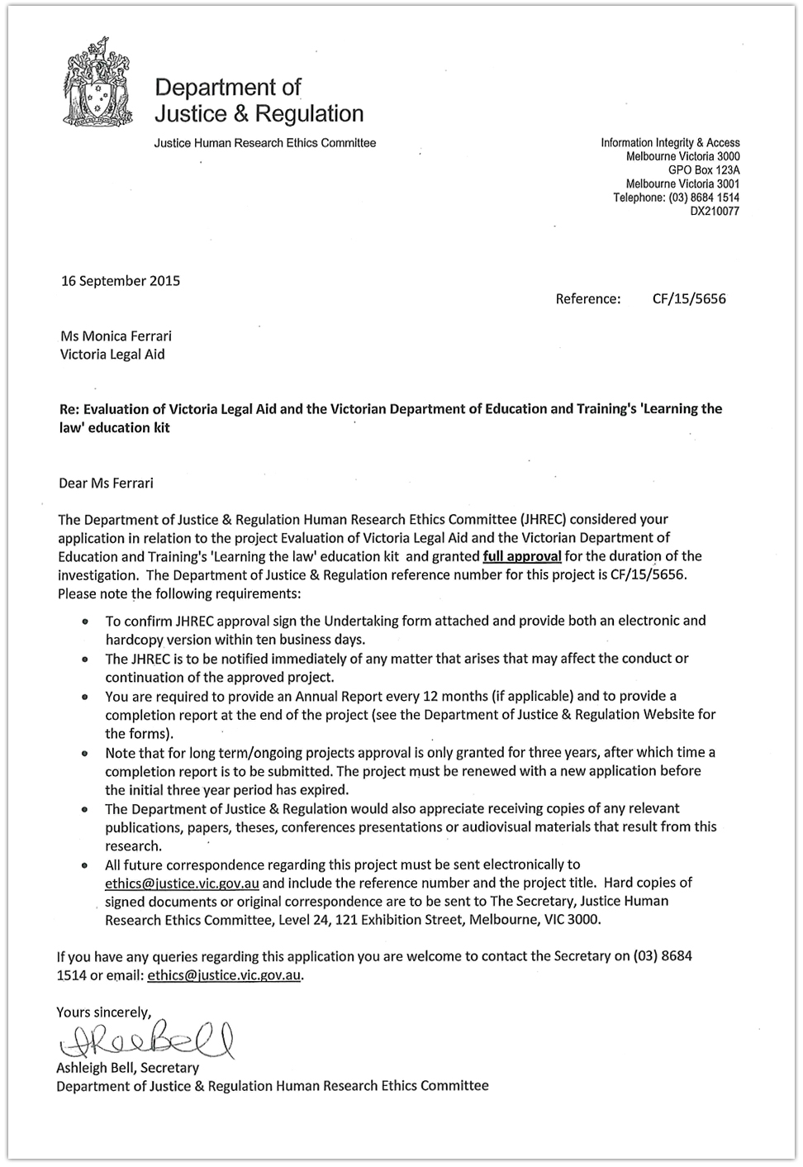
Appendix E – ethics approval
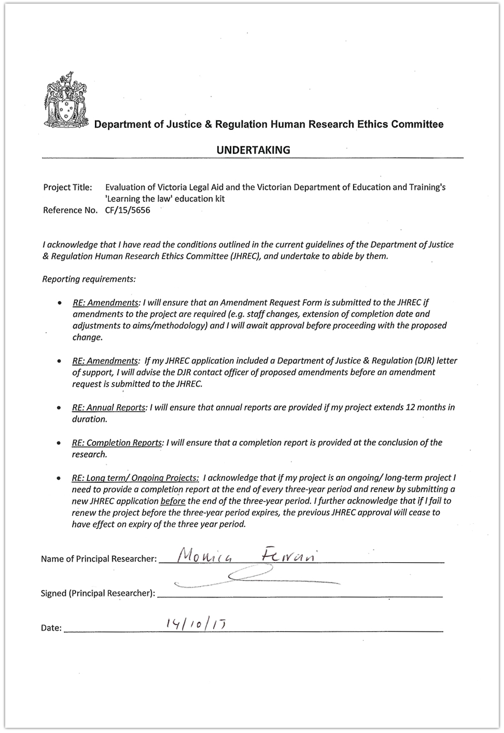

Appendix F: Accessible reports for participants
Our accessible report summarised the results of the research in a thank you card for participants.

Control school report

Test school report
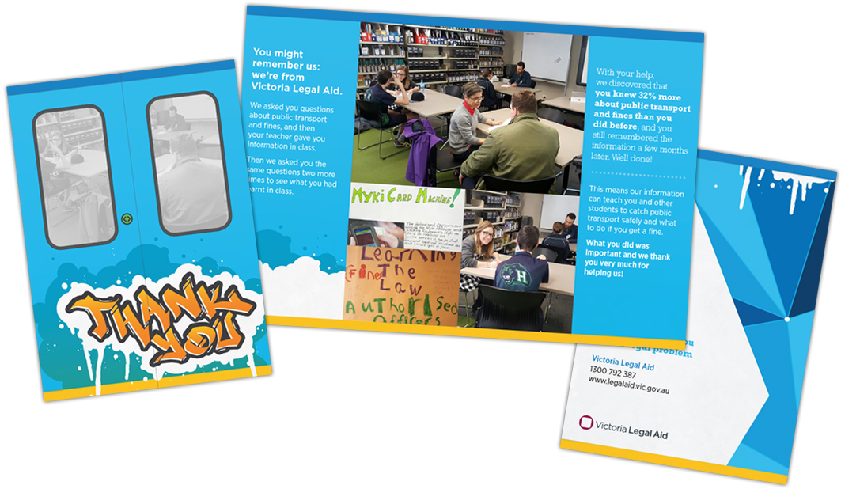

Victoria Legal Aid, Learning the law (2015), online: Victoria Legal Aid <http://www.legalaid.vic.gov.au/find-legal-answers/free-publications-and-resources/learning-law>.
Suzie Forell & Hugh M McDonald, “Beyond Great Expectations: Modest, Meaningful and Measurable Community Legal Education and Information” (2015), Justice Issues Paper 21, Law and Justice foundation of New South Wales, 1-12.
Community legal education – the practice of educating individuals and the community about legal issues. In the UK and Canada CLE is often referred to as public legal education (PLE).
Legal Aid Act 1978, s 6(d) at 12 (Victoria, Australia).
Suzie Forell & Hugh H McDonald, “Evaluation of Legal Service Delivery: Challenges, Opportunities and Work Towards a Framework” (2017), conference paper, International Legal Aid Group Conference, Johannesburg, June 14-16.
Lisa Wintersteiger, Legal Needs, Legal Capability and the Role of Public Legal Education (2015), online: Law for Life: Foundation for Public Legal Education <http://www.lawforlife.org.uk/wp-content/uploads/Legal-needs-Legal-capability-and-the-role-of-Public-Legal-Education.pdf>; Suzie Forell & Hugh M McDonald, “Beyond Great Expectations: Modest, Meaningful and Measurable Community Legal Education and Information” (2015); Dr Melina Buckley, Evolving Legal Services Research Project: Research Design Report, online: Community Legal Education Ontario <http://plelearningexchange.ca/research/research-evolving-legal-services-research-project/>.
Monica Ferrari, “Does Community Legal Education Work? Educating English Language Students about Consumer Contracts” (2015), MA Thesis, RMIT University, Melbourne.
Statistical significance refers to the process of statistical hypothesis testing. This processes calculates the probability of observing a particular sample statistic, or one more extreme, based on the assumption that there is no effect in the population (null hypothesis). If this probability is very small, typically less than a significance level of 0.05, the result can be considered statistically significant.
Catrina Denvir, Nigel J Balmer, & Pascoe Pleasence, “When legal rights are not a reality: do individuals know their rights and how can we tell?” (2013), The Journal of Social Welfare & Family Law, 35(1), 139-160. Online: <http://dx.doi.org/10.1080/09649069.2013.774764>.
Department of Education and Training Victoria, Conducting research in Victorian government schools and early childhood settings: guidelines for applicants (2017), online: <http://www.education.vic.gov.au/about/research/Pages/schoolresearch.aspx>
National Health and Medical Research Council, The National Statement on Ethical Conduct in Human Research (2007), reference number E72, online: <https://www.nhmrc.gov.au/guidelines-publications/e72>
Contact the authors for a copy of the detailed statistical report.

